**Los Angeles Police Department Crime Data Analysis**

**[Mrimon (Nemo) Guha](https://www.linkedin.com/in/mrimon-nemo-guha-917b31133/)**

Table of Contents

Section 1: Introduction 3

Section 2: Data Overview 3

Section 3: Tables created: 3

Section 4: ER Diagram: 4

Section 5: Conversion of database to tables 5

Section 6: Challenges and resolutions 6

Section 7: Data Dictionary 8

Section 8: Business Questions 11

Some of the business questions I believe are important to answer with the dataset are as follows: 11

## **Section 1: Introduction**

Los Angeles is a city that has an area of 500 square miles and is one of the busiest cities in the whole world. It is important for the Los Angeles Police Department (LAPD) to address the rising crimes in the city and cater to public safety. Our analysis provides actionable insights and data backed conclusions to answer some of the key questions across focus areas such as crime types, locations, time patters, victim profiles, status of the cases and the delay in resolving cases.

## **Section 2: Data Overview**

Our data is obtained from the LAPD Open Data Portal ([Link](https://data.lacity.org/Public-Safety/Crime-Data-from-2020-to-Present/2nrs-mtv8)).

It contains data from December 2020 to October 2023. Each row of the dataset is a crime incident with a unique identified (DR NO.).

Primary elements of the dataset:

* ID column for incident
* Date reported and occurred
* Time
* Area details
* Victim demographic
* Crime type
* Weapon description
* Premise (The type of structure, vehicle, or location where the crime took place)
* Investigation status
* Location and street details

Note: Address fields are provided to the nearest hundred block in order to maintain privacy.

## **Section 3: Tables created:**

1. Table 1: Location of crime Table
2. Table 2: Crime details table
3. Table 3: Victim description table
4. Table 4: Premise details table
5. Table 5: Weapons table
6. Table 6: Investigation Status Table
7. Table 7: Calendar Table

## **Section 4: ER Diagram:**

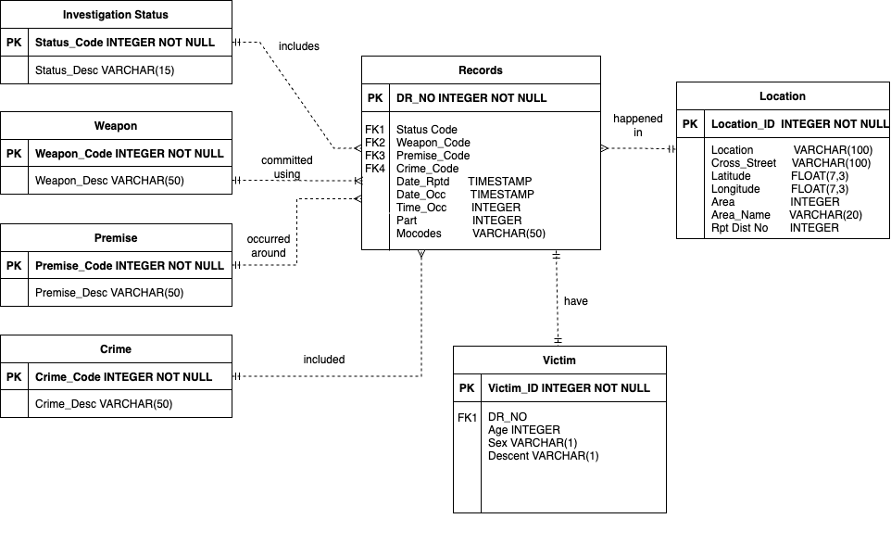

## **Section 5: Conversion of database to tables**

I have converted the database into the tables in the following ways

**Step 1-** I had created a database for the tables

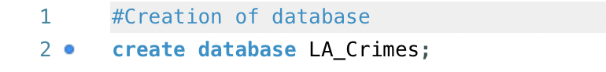

**Step 2-** Post this, using the database, I created tables for all 6 of my tables

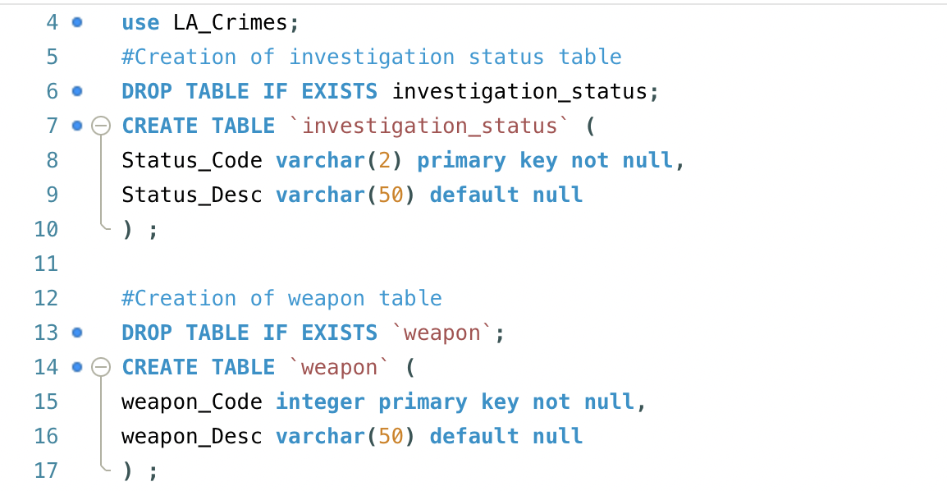

**Step 3-** After this, I inserted records into my tables using “Insert into”

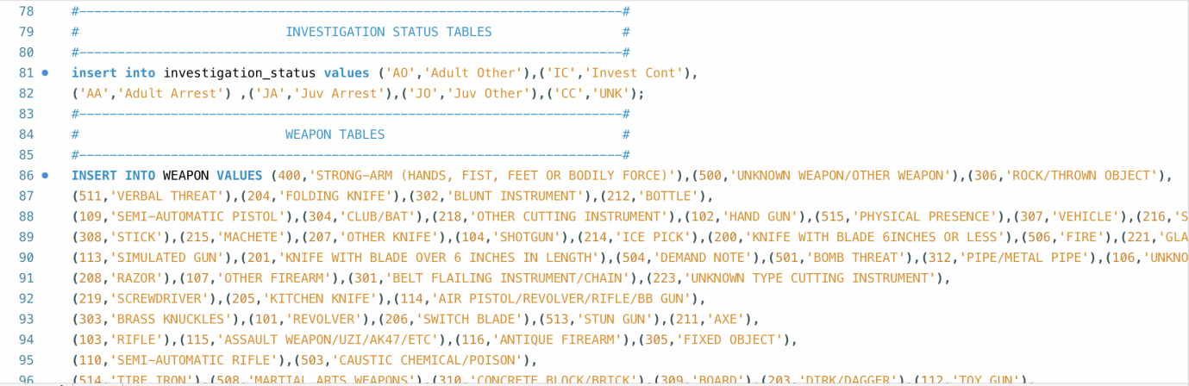

**Step 4-** Querying 5 rows just to check if rows have been inserted or not

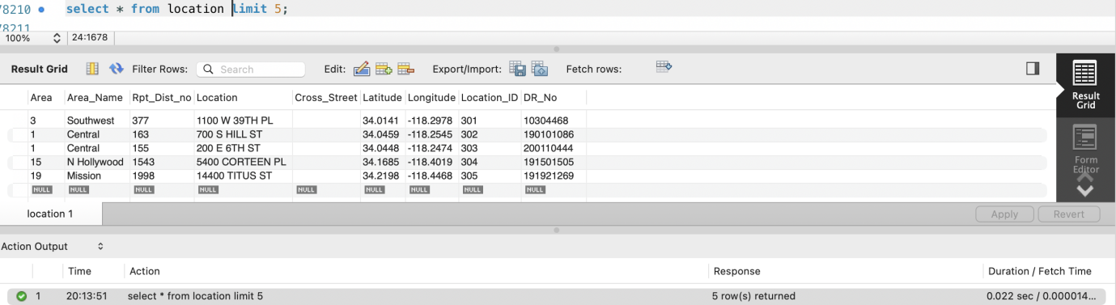

## **Section 6: Challenges and resolutions**

**Challenge 1:** I was not able to create my table and insert values as it displayed a “warning” 1051- it showed that table investigation_status table is already created. I was not able to create the table

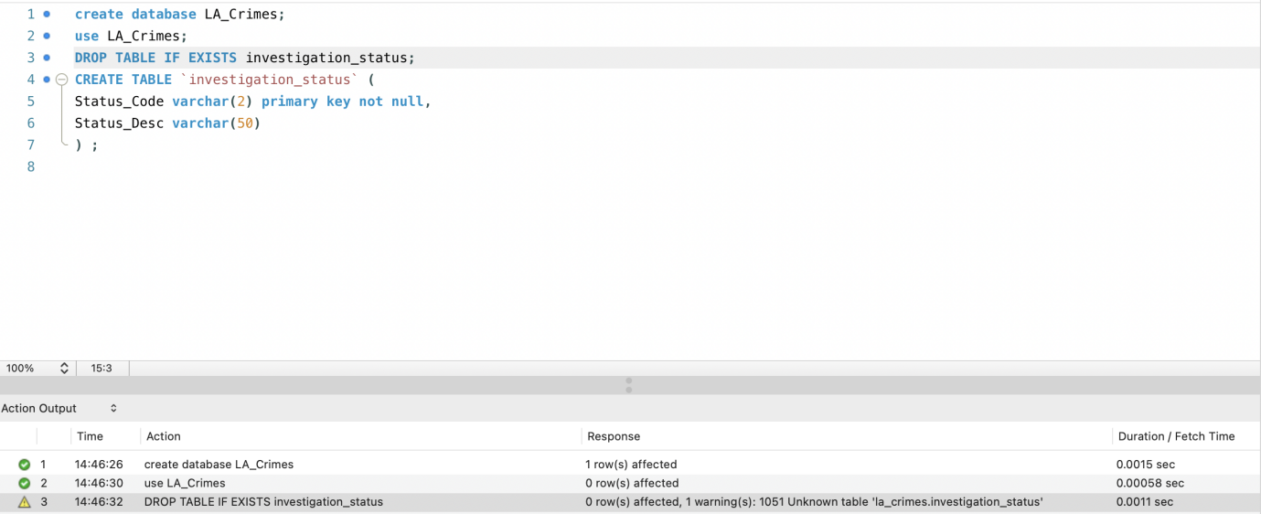**Resolution:** I searched the internet to resolve this ([link](https://stackoverflow.com/questions/36722520/cant-drop-table-because-unknown-table-error-1051)). I had to drop the view investigation_status to create the table with the same name.

**Challenge 2:** ‘ in value. My data had “Gentleman’s club” in values and I was not able to insert the values to the table.

**Resolution:** I had to add another ’ to ensure that the data is properly inserted

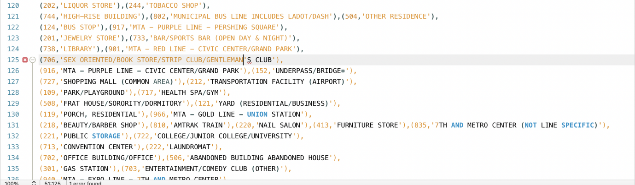

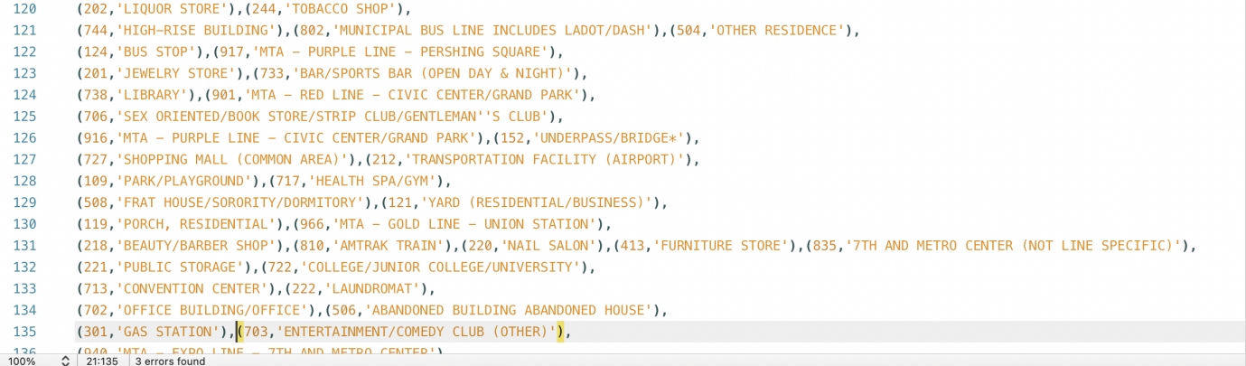

**Challenge 3:** Size of the data is bigger due to extra blank spaces

**Resolution:** I had to trim the extra spaces in Excel to ensure that we do not insert extra spaces into the dataset

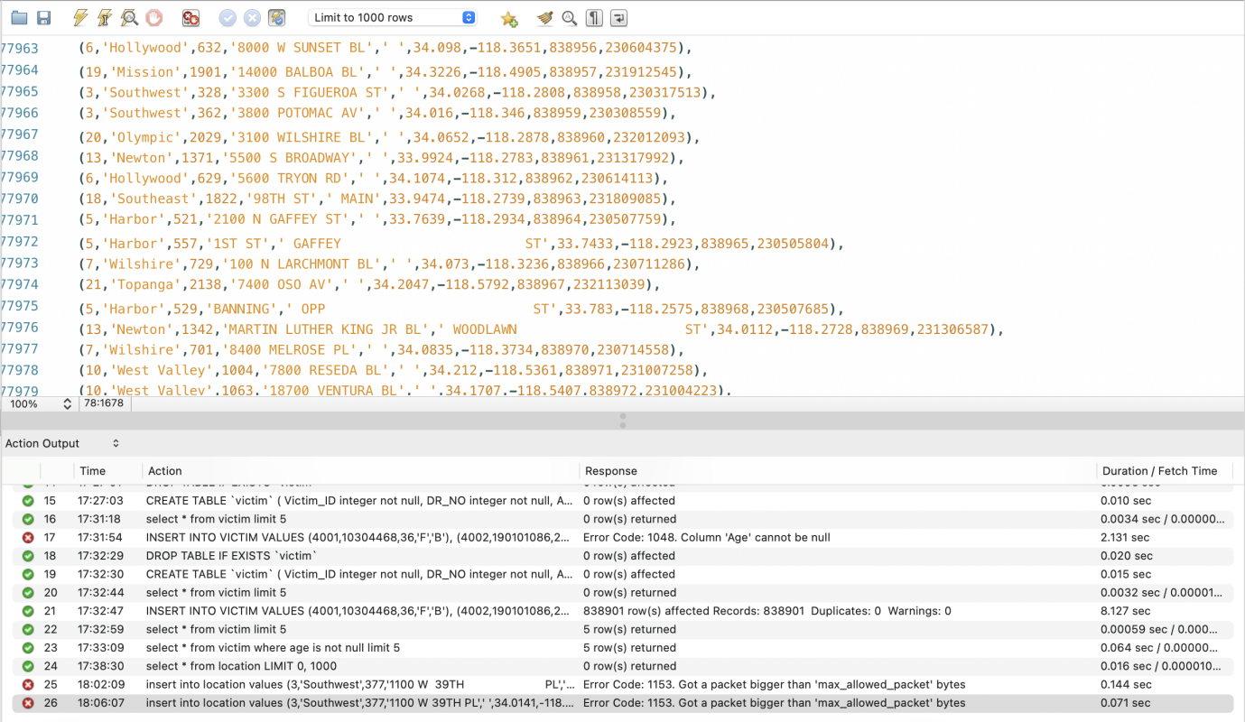

## **Section 7: Data Dictionary**

**Table Name: Investigation Status**

|  |  |  |  |  |
| --- | --- | --- | --- | --- |
| **Column Name** | **Description** | **Datatype** | **Size** | **Example** |
| Status_Code | Contains the code for the investigation status | Varchar | 2 | IC |
| Status_Desc | Description of code | Varchar | 50 | Investigation Continued |

**Table Name: Weapon**

|  |  |  |  |  |
| --- | --- | --- | --- | --- |
| **Column Name** | **Description** | **Datatype** | **Size** | **Example** |
| Weapon_Code | Contains the code for the weapon used in the crim | Integer | 3 | 400 |
| Weapon_Desc | Description of the weapon used | Varchar | 50 | STRONG-ARM (HANDS, FIST, FEET OR BODILY FORCE) |

**Table Name: Premise**

|  |  |  |  |  |
| --- | --- | --- | --- | --- |
| **Column Name** | **Description** | **Datatype** | **Size** | **Example** |
| Premise_Code | The type of structure, vehicle, or location where the crime took place | Integer | 3 | 102 |
| Premise_Desc | Defines the premise code provided | Varchar | 70 | Sidewalk |

**Table Name: Crime**

|  |  |  |  |  |
| --- | --- | --- | --- | --- |
| **Column Name** | **Description** | **Datatype** | **Size** | **Example** |
| Crime_Code | Contains the code for the type of crime committed | Integer | 3 | 624 |
| Crime_Desc | Description of the crime committed | Varchar | 60 | Battery-Simple Assault |

**Table Name: Victim**

|  |  |  |  |  |
| --- | --- | --- | --- | --- |
| **Column Name** | **Description** | **Datatype** | **Size** | **Example** |
| Victim ID | ID of the victim | Integer | 10 | 4001 |
| DR_NO | Division of Records Number: Official file number made up of a 2 digit year, area ID, and 5 digits | Integer | 15 | 10304468 |
| Age | Age of the victim | Integer | 3 | 25 |
| Sex | Sex of the victim | Varchar | 1 | M |
| Descent | Descent Code: A - Other Asian B - Black C - Chinese D - Cambodian F - Filipino G - Guamanian H - Hispanic/Latin/Mexican I - American Indian/Alaskan Native J - Japanese K - Korean L - Laotian O - Other P - Pacific Islander S - Samoan U - Hawaiian V - Vietnamese W - White X - Unknown Z - Asian Indian | Varchar | 1 | A |

**Table Name: Location**

|  |  |  |  |  |
| --- | --- | --- | --- | --- |
| **Column Name** | **Description** | **Datatype** | **Size** | **Example** |
| Area | The LAPD has 21 Community Police Stations referred to as Geographic Areas within the department. These Geographic Areas are sequentially numbered from 1-21. | Integer | 2 | 3 |
| Area_Name | The 21 Geographic Areas or Patrol Divisions are also given a name designation that references a landmark or the surrounding community that it is responsible for. For example 77th Street Division is located at the intersection of South Broadway and 77th Street, serving neighborhoods in South Los Angeles. | Varchar | 15 | N Hollywood |
| Rpt_Dist_no | A four-digit code that represents a sub-area within a Geographic Area. All crime records reference the "RD" that it occurred in for statistical comparisons. | Integer | 4 | 1543 |
| Location | Street address of crime incident rounded to the nearest hundred block to maintain anonymity. | Varchar | 50 | 5400 Corteen PL |
| Cross_Street | Cross Street of rounded Address | Varchar | 50 | Olive |
| Latitude | Latitude | Decimal | (2,4) | 38.9431 |
| Longitude | Longitude | Decimal | (3,3) | -118.449 |
| Location_ID | Location ID | Integer | 6 | 839201 |
| DR_No | Division of Records Number: Official file number made up of a 2 digit year, area ID, and 5 digits | Integer | 15 | 10304468 |

**Table Name: Records**

|  |  |  |  |  |
| --- | --- | --- | --- | --- |
| **Column Name** | **Description** | **Datatype** | **Size** | **Example** |
| DR_No | Division of Records Number: Official file number made up of a 2 digit year, area ID, and 5 digits | Integer | 15 |  |
| Status_Code | Contains the code for the investigation status | Varchar | 2 | IC |
| Weapon_Code | Contains the code for the weapon used in the crim | Integer | 3 | 400 |
| Premise_Code | The type of structure, vehicle, or location where the crime took place | Integer | 3 | 102 |
| Date_Rptd | Date reported | Datetime |  | 04/14/2020 12:00:00 AM |
| Date_occ | Datetime of crime | Datetime |  | 04/14/2020 12:00:00 AM |
| Time_occ | Time In 24 hour military time. | Integer | 5 | 1130 |
| Part_1_to_2 | Part of the dataset | Integer | 1 | 1 |
| Mocodes | Modus Operandi: Activities associated with the suspect in commission of the crime | Integer | 15 | 0444 0913 |
| Crime_code | Contains the code for the type of crime committed | Integer | 3 | 624 |

## 

## 

## **Section 8: Business Questions**

## Some of the business questions I believe are important to answer with the dataset are as follows:

**Question 1**

In a big city like Los Angeles, there are several different kinds of crimes being committed every day. The head of the police department wants to know which type of crimes are most committed to ensure that they can distribute the workforce and train them accordingly.

**Approach**I have grouped the crime descriptions and displayed the number of incidents (records)

**Visualizations**

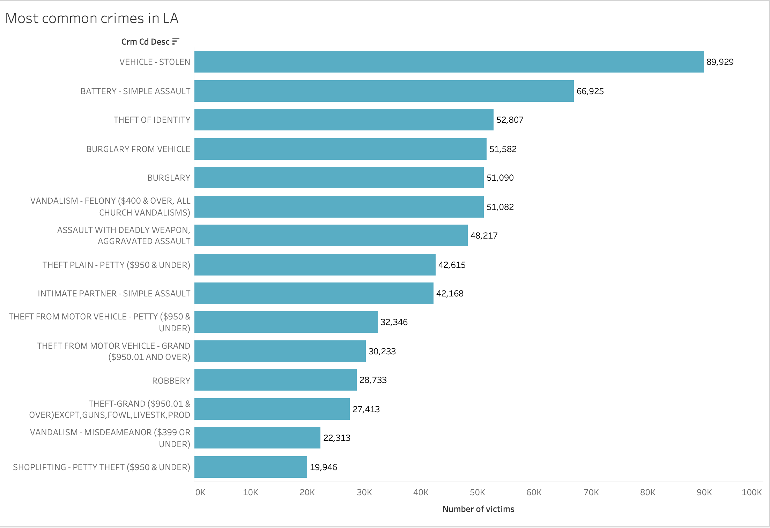

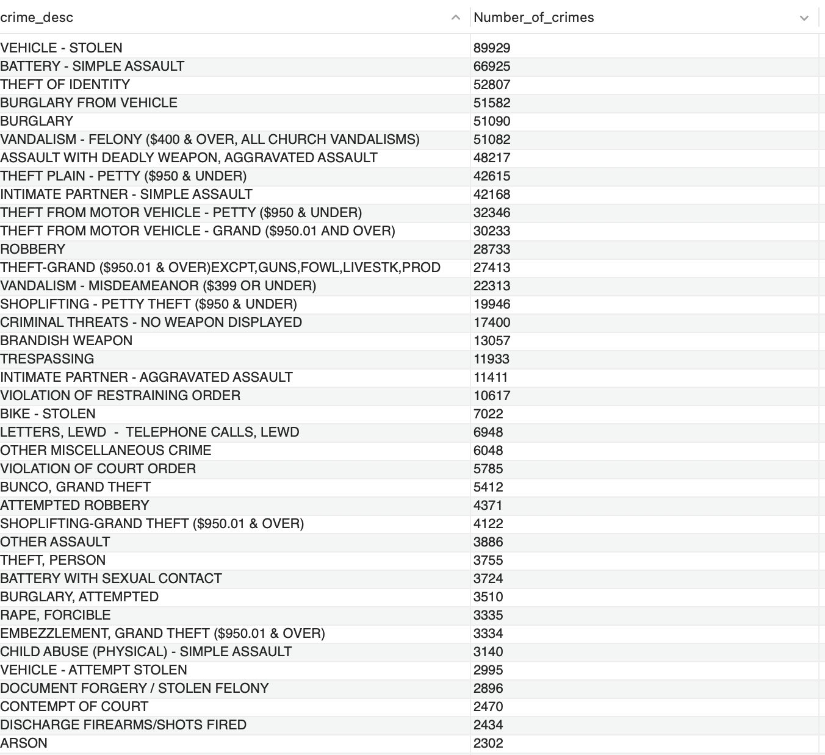

**Insight**Vehicles being stolen, assaults, identity theft and burglaries are the most common crimes in LA.  
  
**Question 2**

Furthermore, He wants to update their LAPD website to ensure that civilians and tourists are aware of potential unsafe areas. He wants to know which areas have the most crimes being committed and what sort of crimes are common in these areas. Preferably a list of top 5 areas with most crimes and the type of crimes would be ideal for his future action items.

**Approach**Building on top of the above question, I added a ranking based on the number of crimes for the areas in LA. Rank-1 indicates most common crime in that area.

**Visualizations**

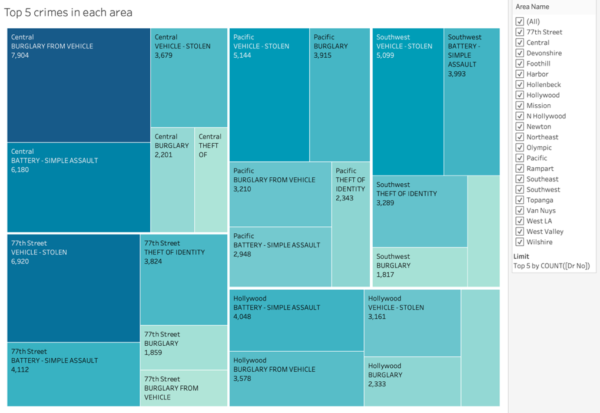

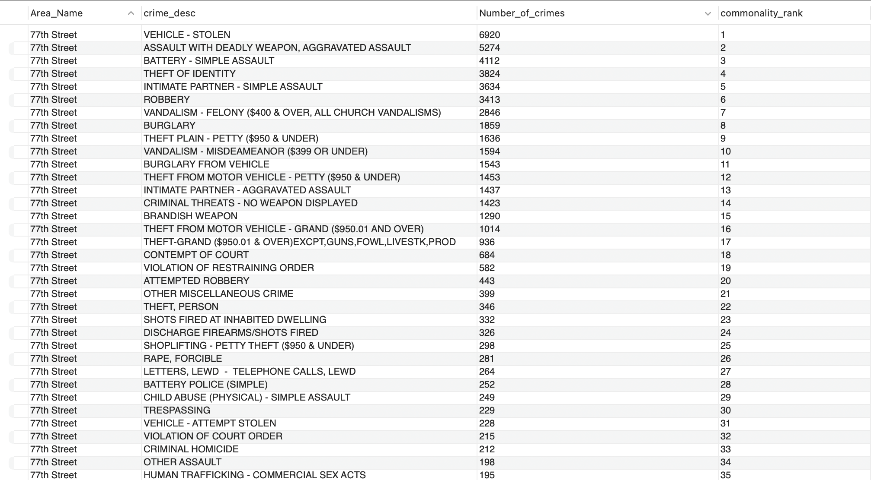

**Insight**

We can observe that burglary from a vehicle and stolen vehicle are two types of the most common crimes in Central LA and 77th Street respectively. We can also find out crimes for other areas.

**Question 3**

What time of the day are crimes most likely to happen in which areas? Also, find the average age of victims for these areas and crimes

**Approach**

I selected the time, number of incidents, average age for each area and type of crime committed. **Visualizations**

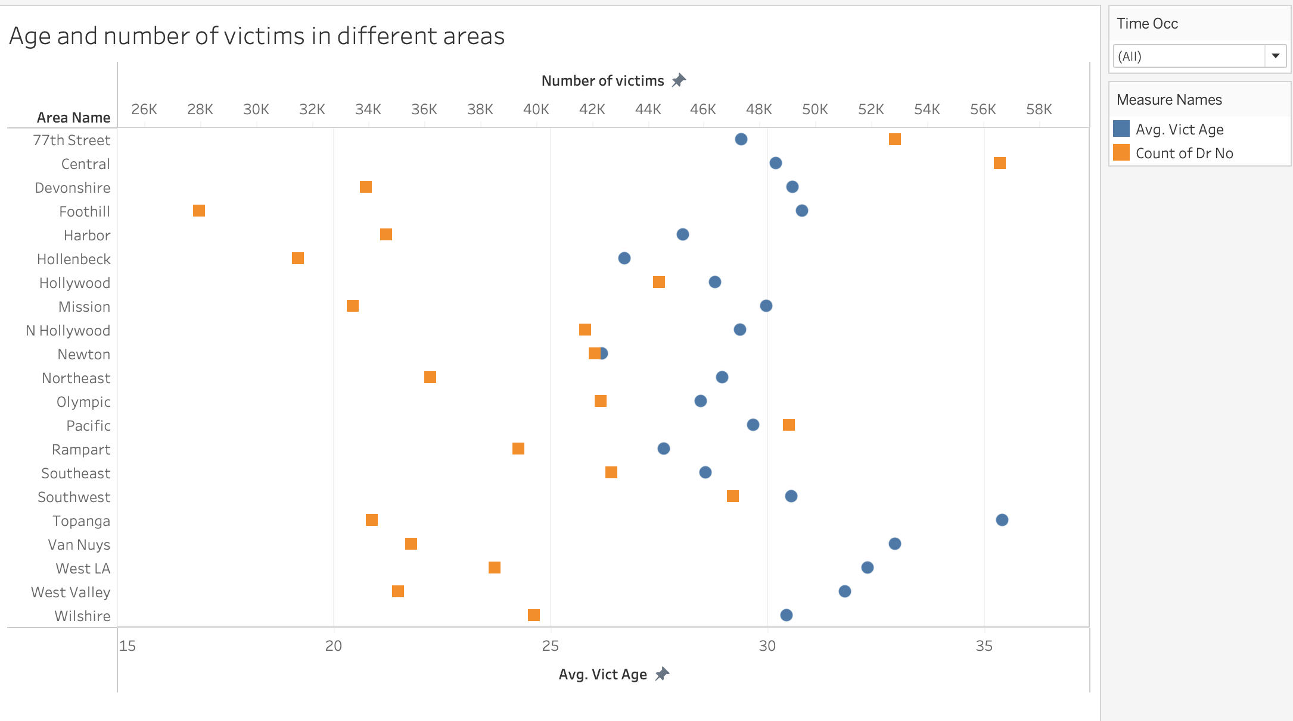

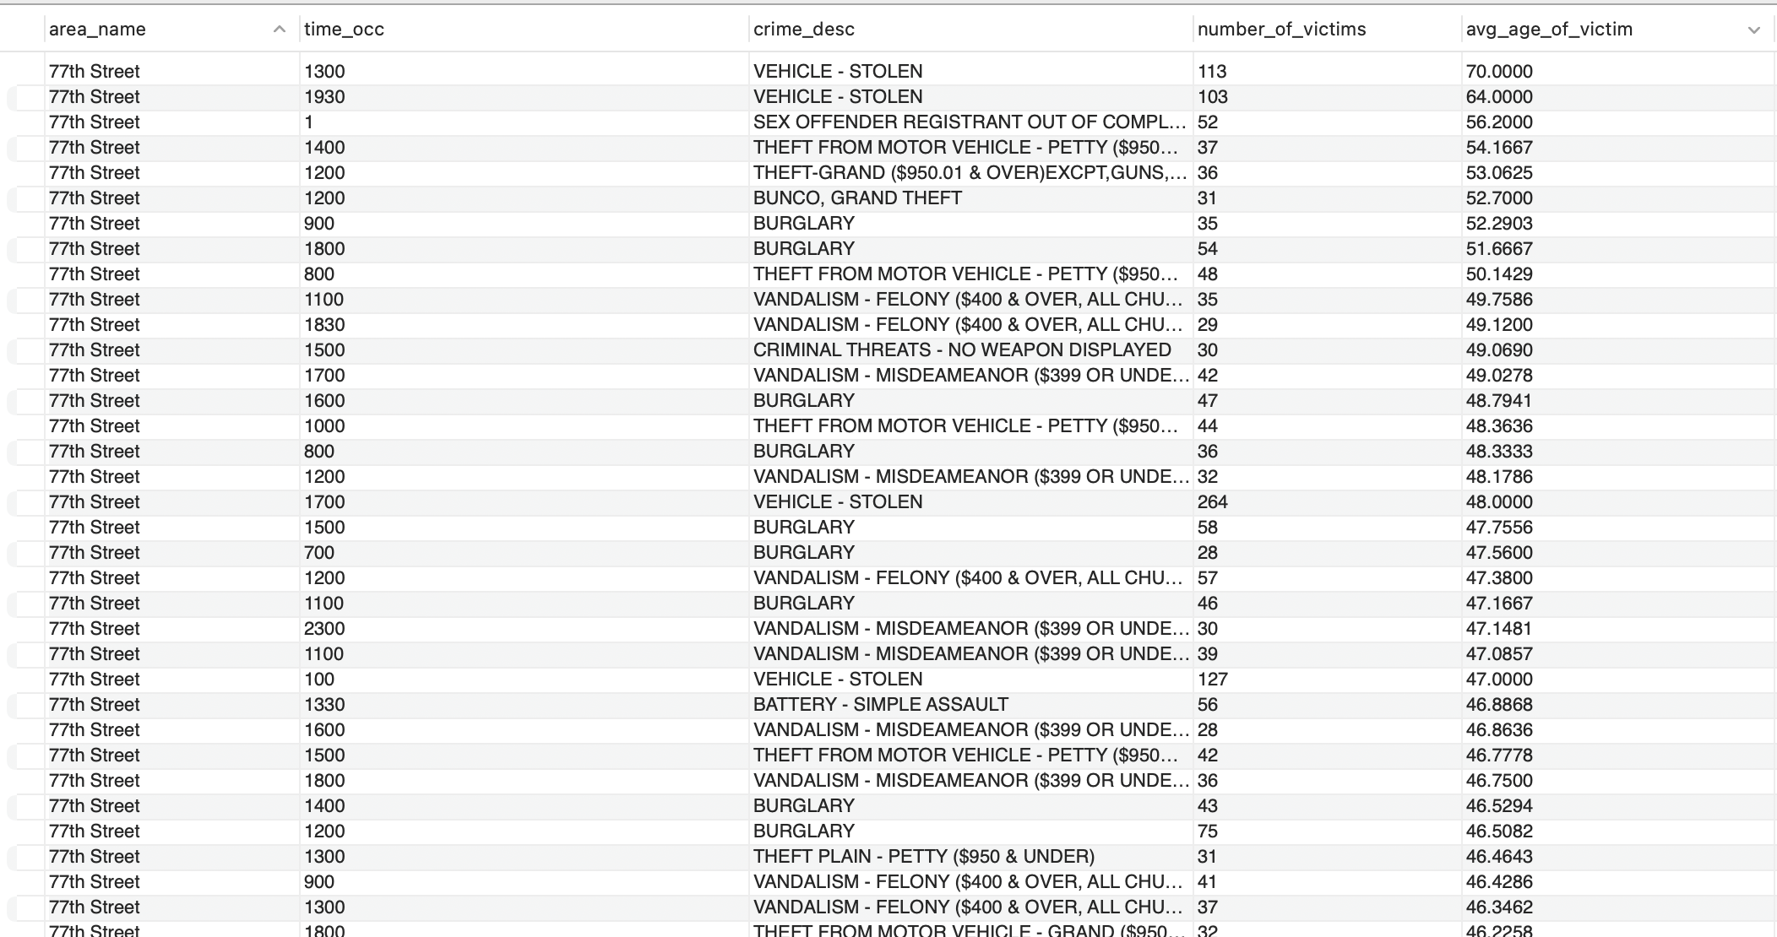

**Insight**

Vehicles being used by senior citizens in the 77th street area can get stolen, especially around 1 PM and 7 PM.

**Question 4**

Are victims belonging to one particular descent or do they belong to a particular gender. Is there any correlation between age, sex, descent with crime?

**Approach**Displaying the number of victims across age, sex, descent. **Visualizations**

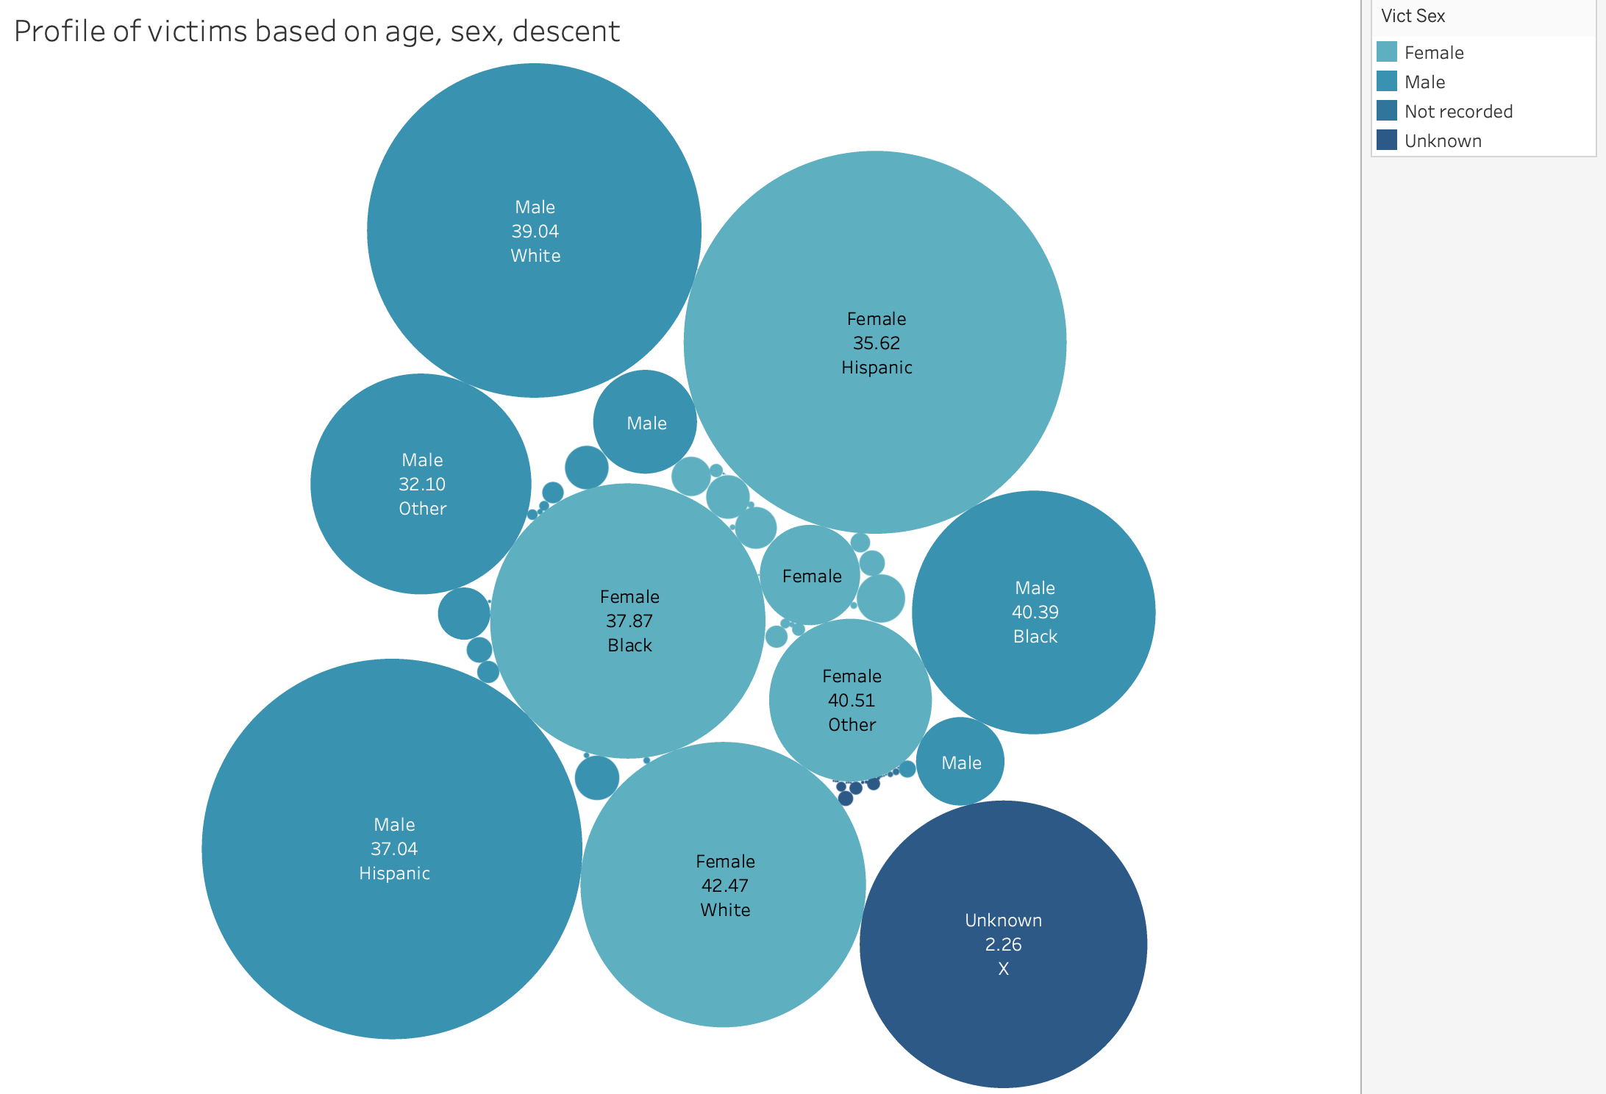

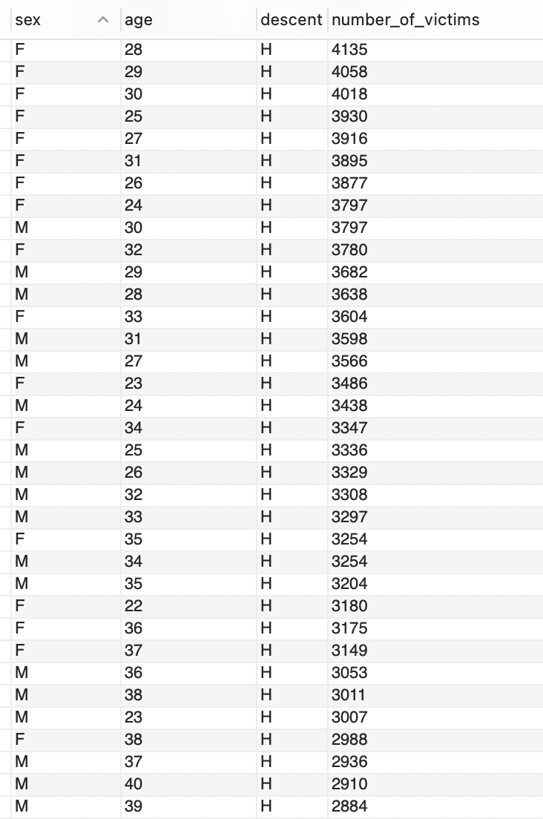

**Insight**Hispanic females aged around 28 are the most common victims of crimes.

**Question 5**

Display two sets of victims one with “youngest” victim age, the other with “oldest” victim age along with their age, area of crime and crime type.

**Approach**

First step is to find the youngest age group and the oldest age group based on their ages, then combining both these individual results to represent the entire result dataset.

**Visualizations**

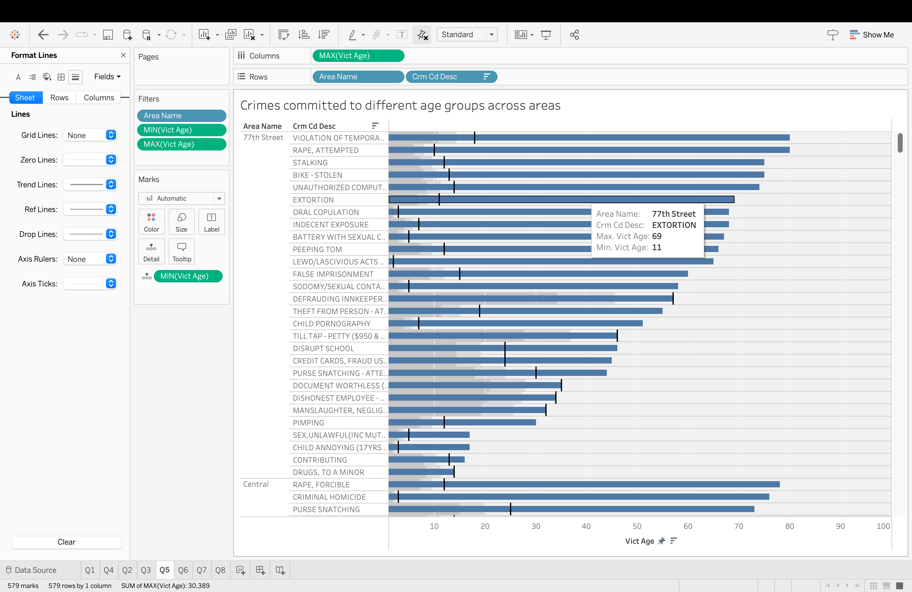

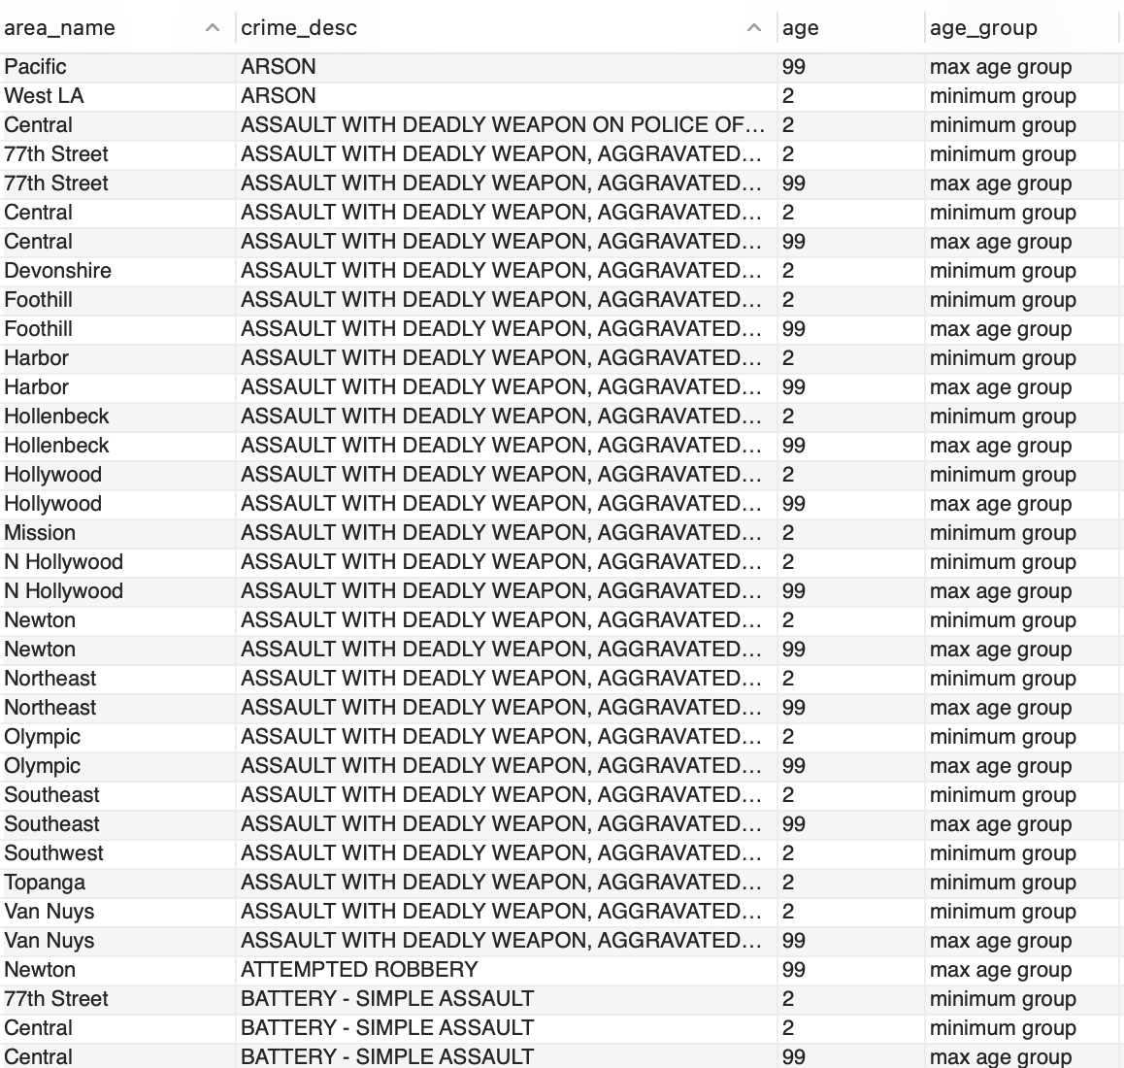

**Insight**

For a crime like extortion, the victims belonged to an age group of 11 through 69

**Question 6**

What is the most common status of cases and is there a pattern of crimes that are being neglected?

**Approach**

Grouping the cases based on their investigation status

**Visualizations**

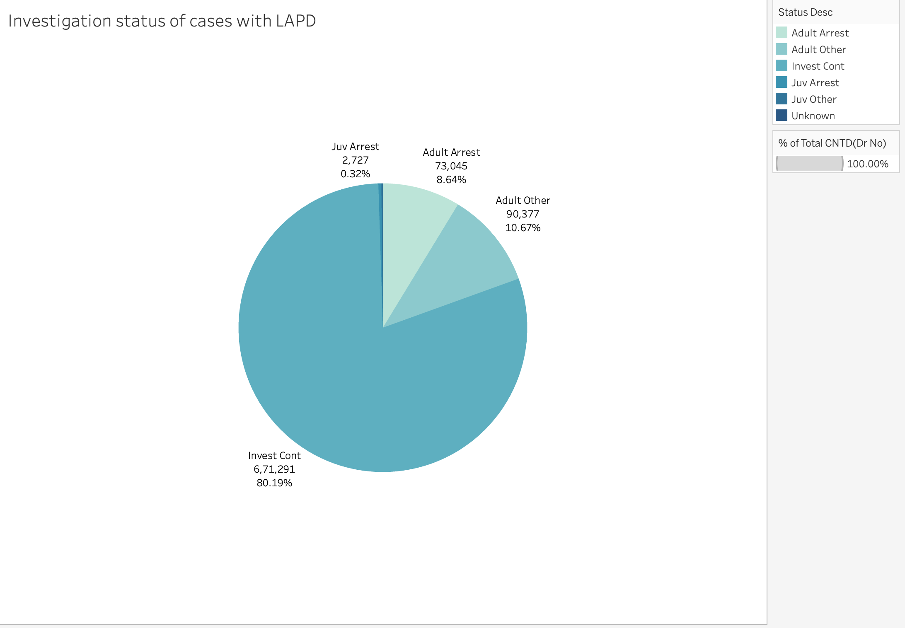

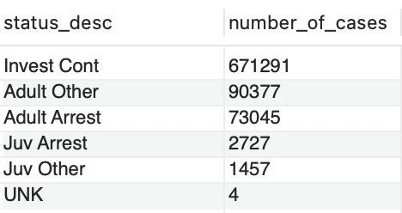

**Insight**

Most of the cases are have the status of investigation being continued i.e. they are still being investigated and not closed or on hold.

**Question 7**

Which are some of the oldest cases and what is the status for these cases and how old are they in terms of number of days?

**Approach**I found the average number of days for each case based and their latest investigation status  **Visualizations**

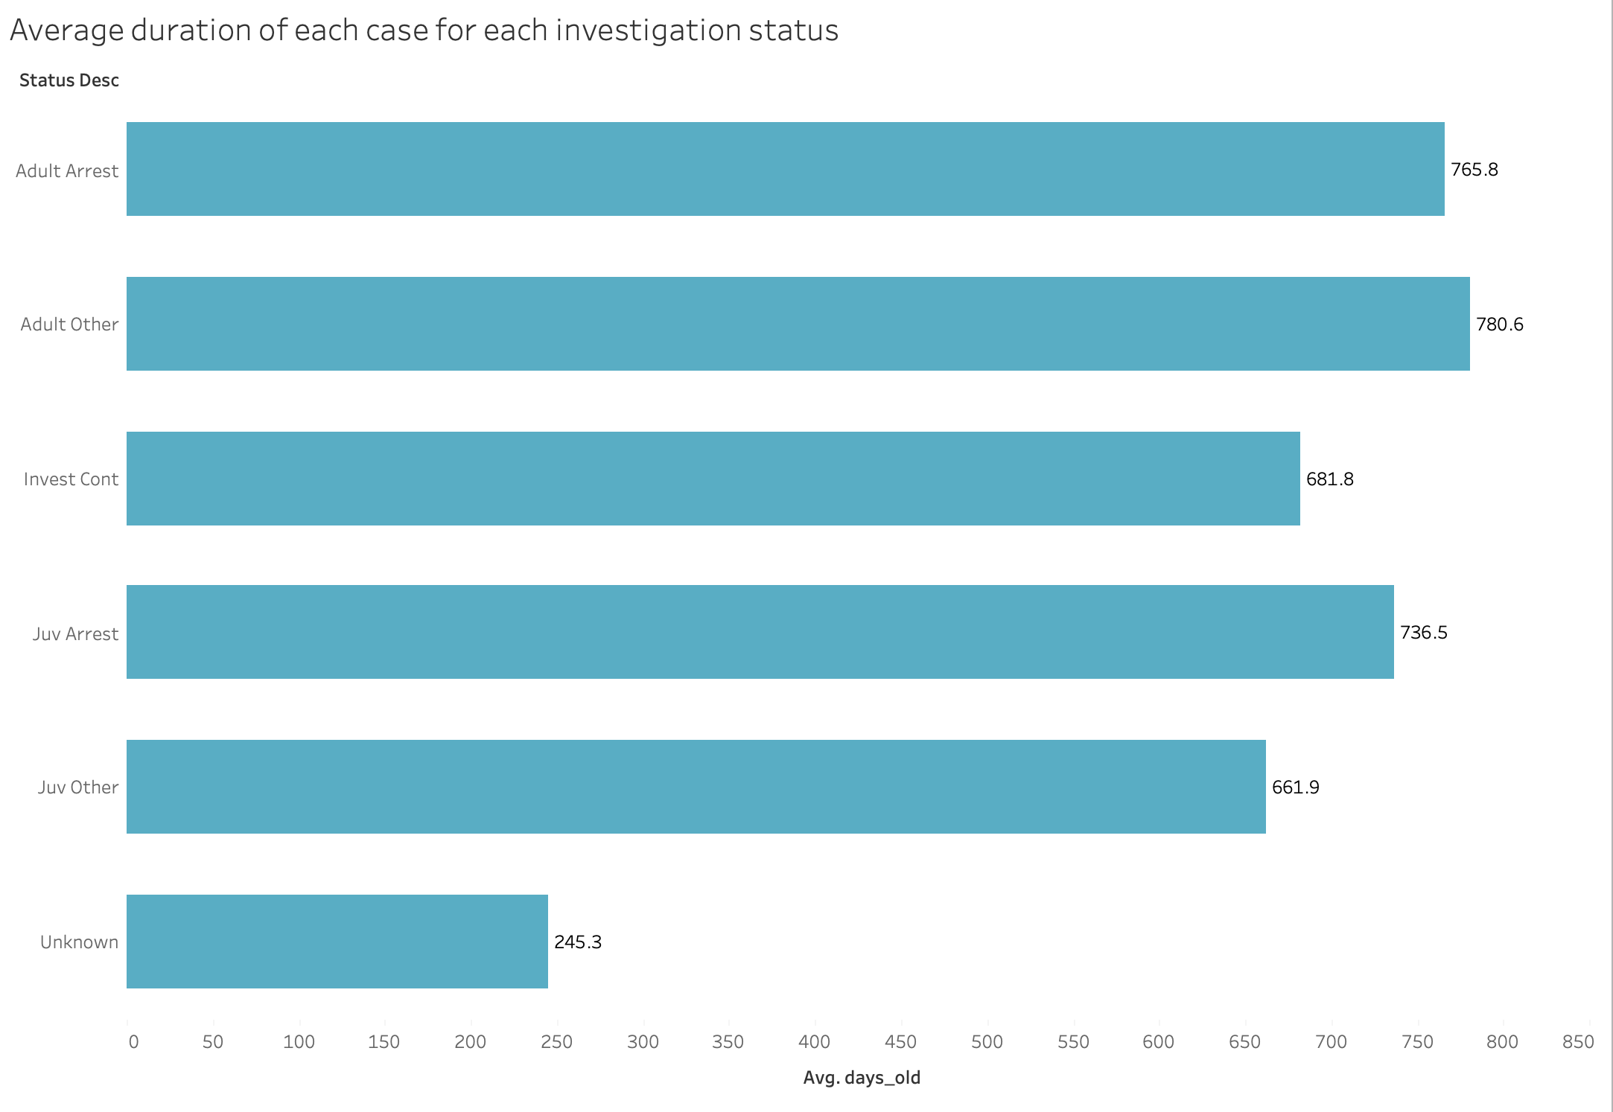

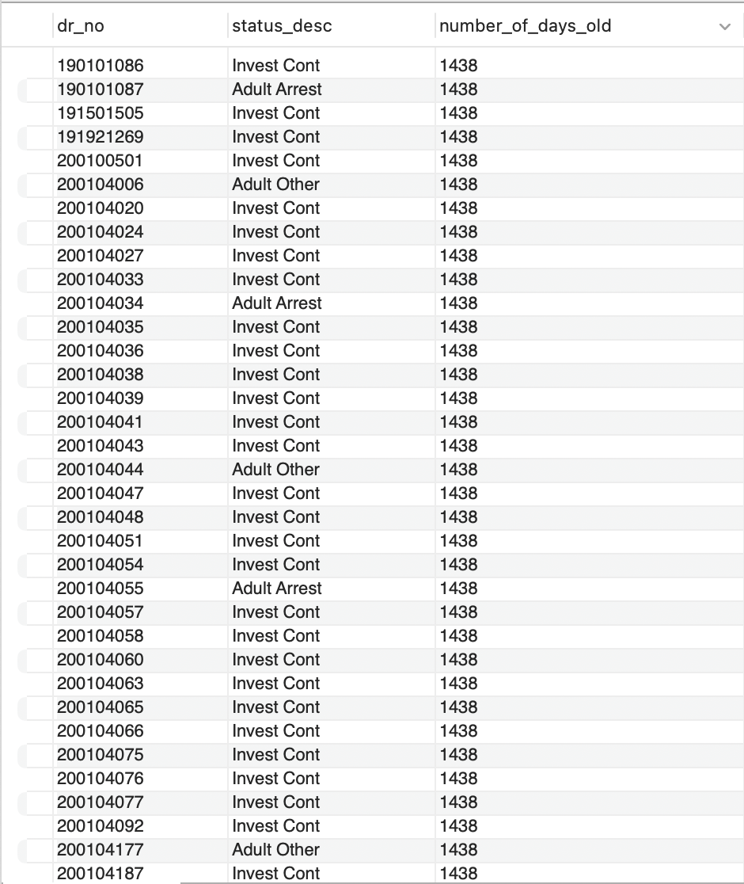

**Insight**

There are lot of cases such as 190101086 that are over 4 years old and are still investigation continued stage. Probably, this reflects that we need to close these cases or update the status accordingly.

**Question 8**

Are there certain premises which are more unsafe than the others and certain areas which are not good?

**Approach**

I have categorised premises and areas based on the number of cases in that area and premise. Anything within top 5 number of cases is a bad area or premise.

**Visualizations**

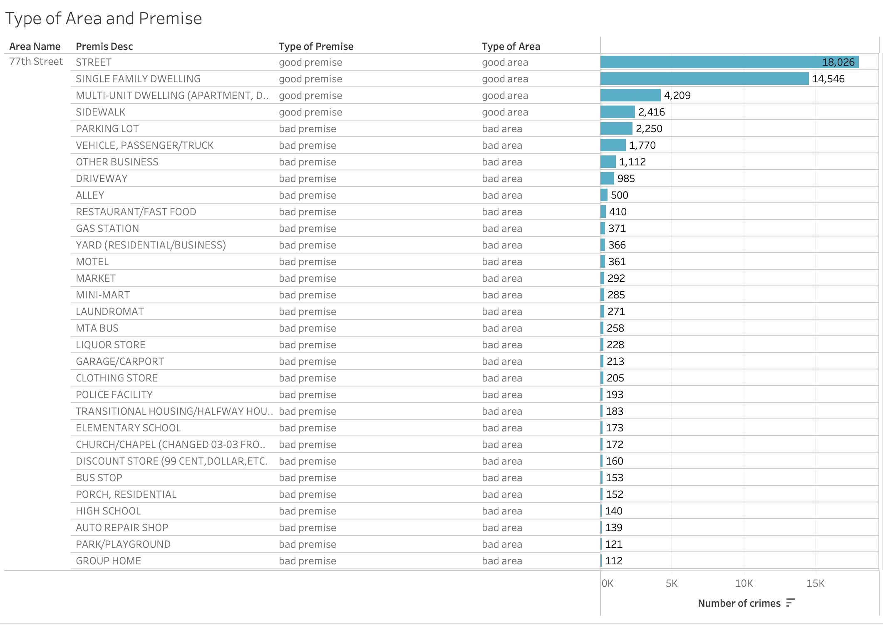

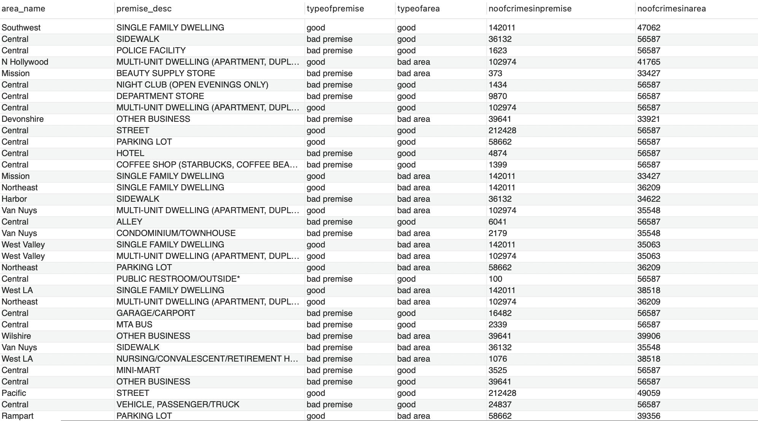

**Insight**

In 77th Street, streets, single family dwellings are good premises.

**Question 9**

People want to know how safe their areas are especially for kids or people who live with dependent and old parents. Create a report of the number of kidnapping crimes for each areas along with the weapons used for committing them and how the police department have treated these cases, it would also benefit them if they could see a profile of age group of victims.

**Approach**

I grouped the victims based on their ages for each area and weapon, I displayed the number of weapons used along with the crimes committed and number of crimes for those weapons also the status of the cases.

**Visualizations**

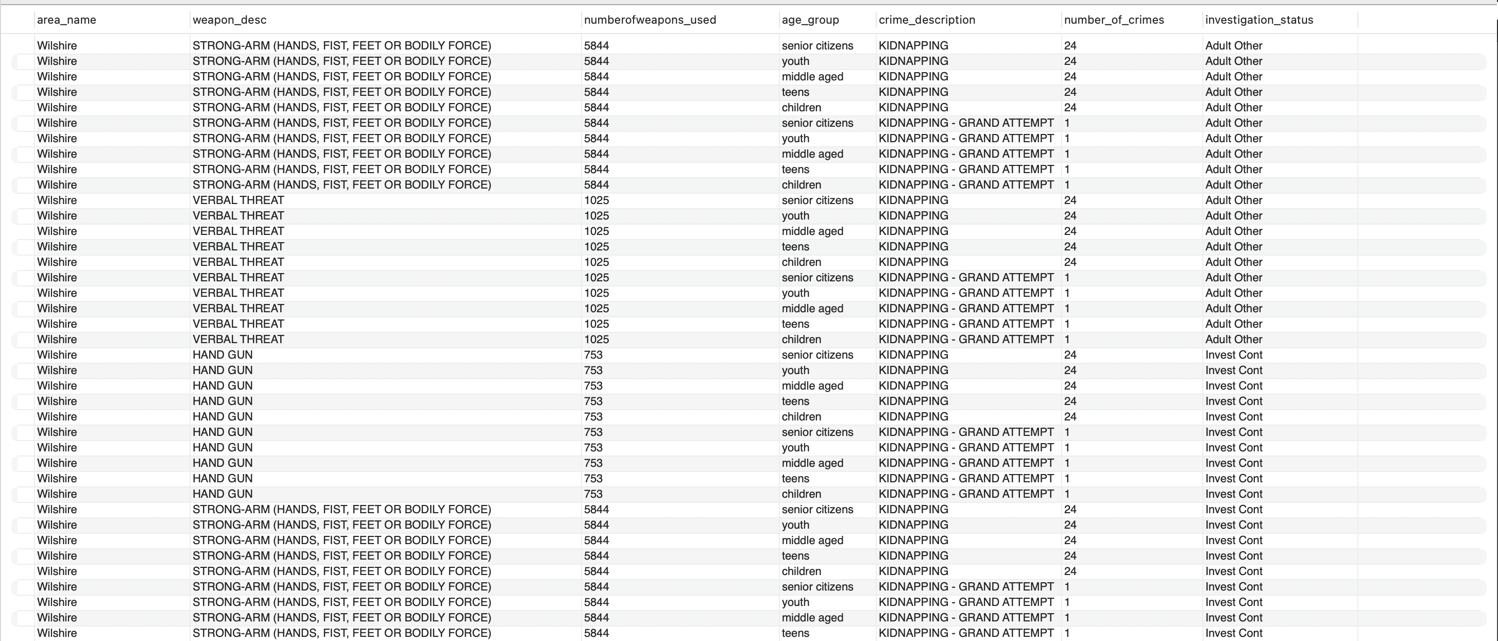

**Insight**

Senior citizens are victims to kidnapping and most of the kidnappings happen with hands, fists.